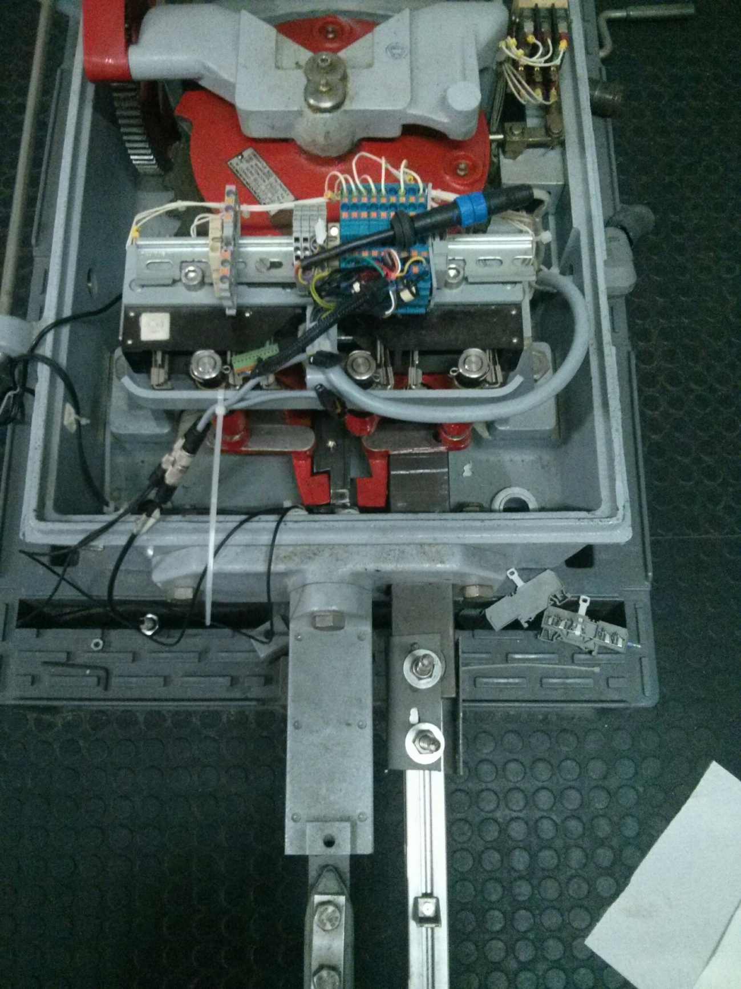

Gears

Lock bars or Detector bars

Lock Hammers

Stretcher or Throw bar

Electric detector contacts